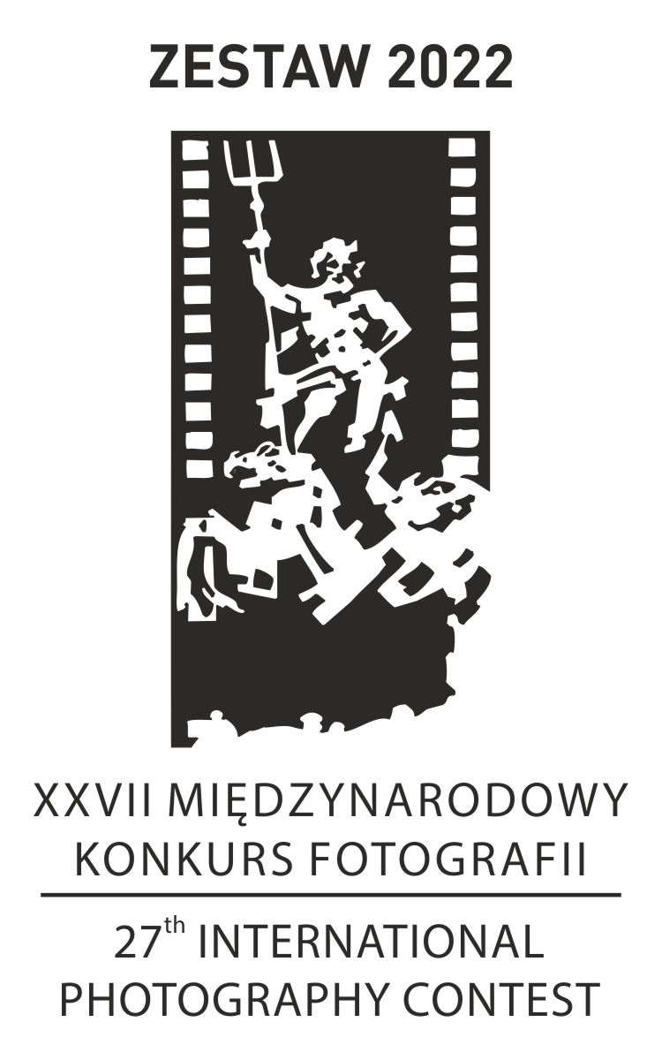
ENTRY FORM
ATTENTION:
Entries without a correctly filled in
and signed Entry Form will not be accepted.
in the contest.
PLEASE COMPLETE IN BLOCK CAPITALS

AUTHOR OF THE SET:
name and surname: ....................................................................................................................... .
address: ........................................................................................................................................ ..
e-mail address: ............................................................................................................................ ...
phone number: .................................................................................................................................

TITLE OF THE SET:

....................................................................................................................................................

I agree to my personal data included in the Application Form being processed for the XXVII International Photography Contest ZESTAW 2022. I acknowledge that providing the data is necessary to participate in the Contest, that my data will be used in accordance with Regulation (EU) 2016/679 of the European Parliament and of the Council of 27 April 2016 on the protection of natural persons with regard to the processing of personal data and on the free movement of such data, and repealing Directive 95/46/EC (General Data Protection Regulation).

□ YES □ NO

I acknowledge that during the award ceremony photographic and film documentation will be made to record the images of the participants in the ceremony. I agree that the Contest Organiser may publicly use, record and reproduce this documentation for promotional and advertising purposes, place it in the press, media, the Internet and other forms of recordings suitable for dissemination, providing the author's data, without time and quantity limits.

□ YES □ NO
I agree to the publication of my image recorded during the award ceremony on the profile of the Miejska Biblioteka Publiczna w Świdnicy (Świdnica Municipal Public Library), Świdnicki Ośrodek Kultury (Świdnica Cultural Centre) on Facebook. I accept that this consent implies the transfer of personal data outside the EU economic area, which does not guarantee the same level of personal data protection as the regulations in force within it.

□ YES □ NO

I declare that the submitted works are my own.
..................................................................
date and signature of the author

